

***INSTITUTE OF INFORMATION TECHNOLOGY***

***JAHANGIRNAGAR UNIVERSITY***

**Number of Assignment :** 01

**Submission Date :** 30/11/2020

**Course Tittle :** Database Management System Lab

**Course Code :** ICT - 2204

**Submitted To Submitted By**

Manan Binth Taj Noor Md. Shakil Hossain

Lecturer Roll – 2023

IIT – JU 2nd year 2nd Semester

IIT – JU

**Creating Order Table**

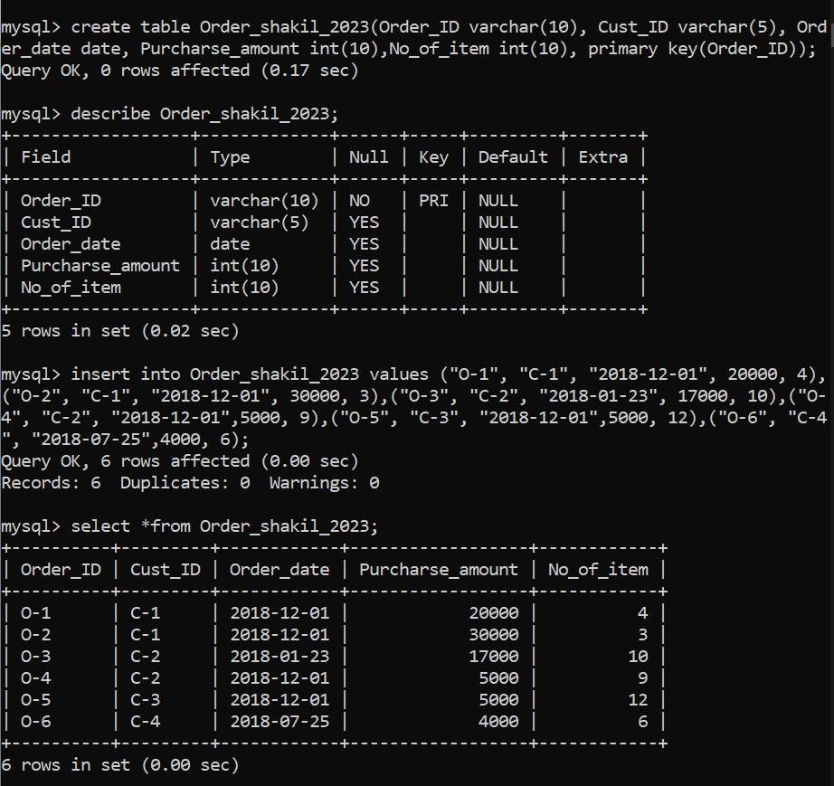

**Creating Customers Table :**

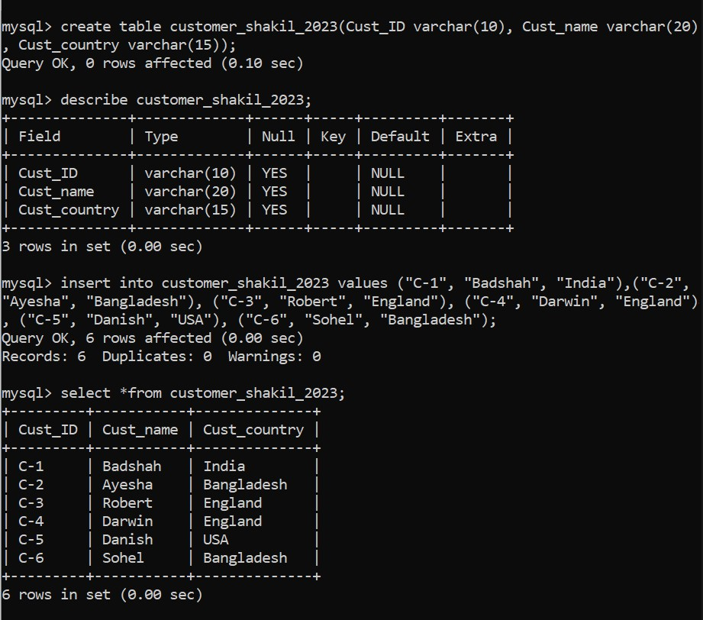

**Shippers Table :**

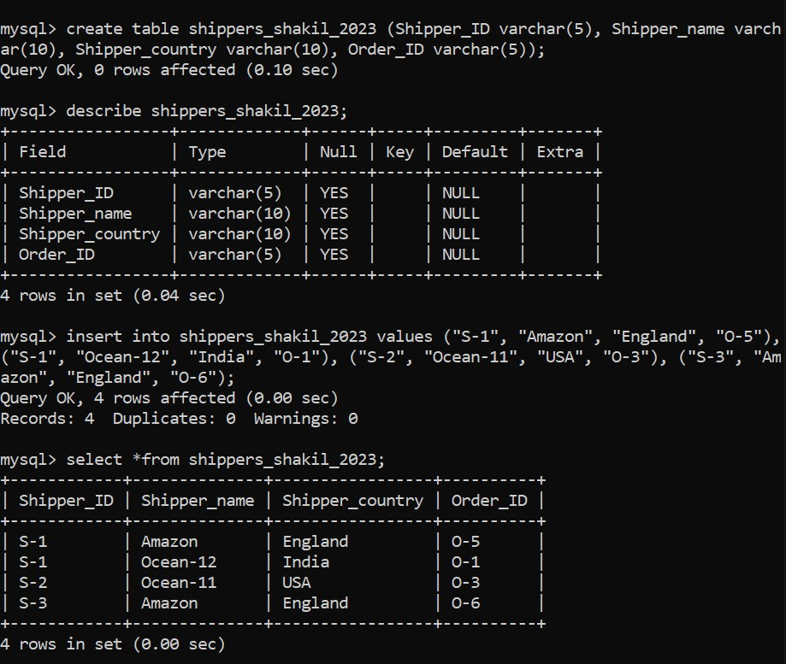

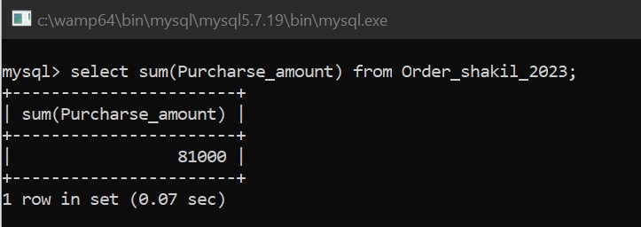**Answer - 1 :**

**Answer - 2:**

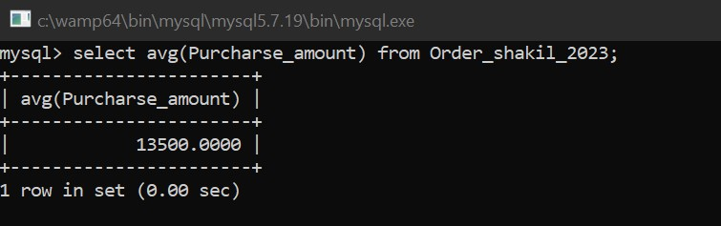

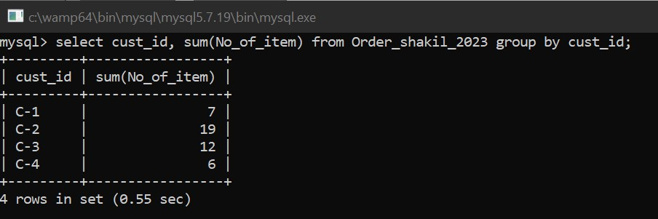**Answer - 3:**

**Answer - 4 :**

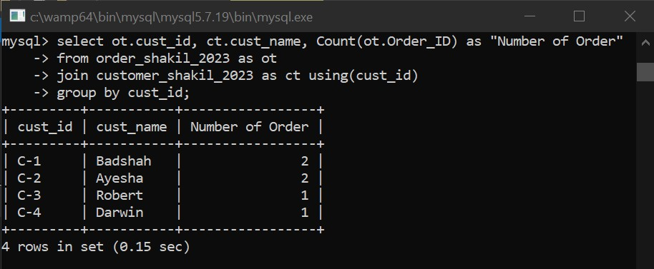

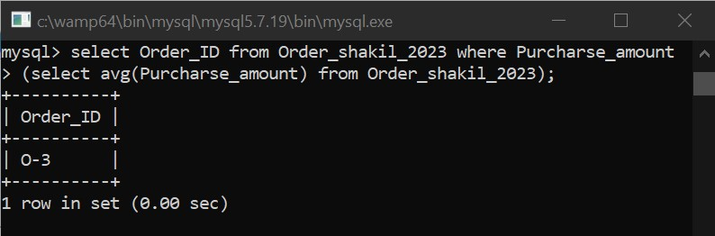**Answer - 5 :**

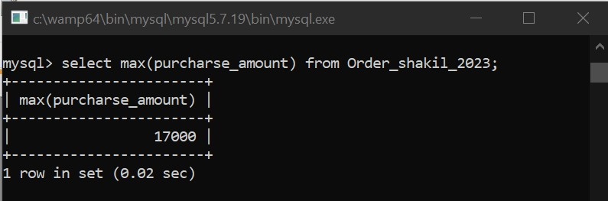**Answer - 6:**

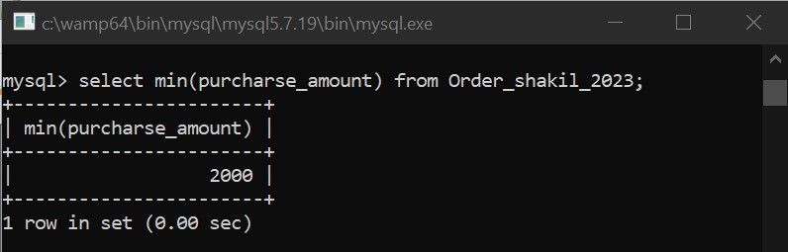**Answer - 7 :**

**Answer - 8:**

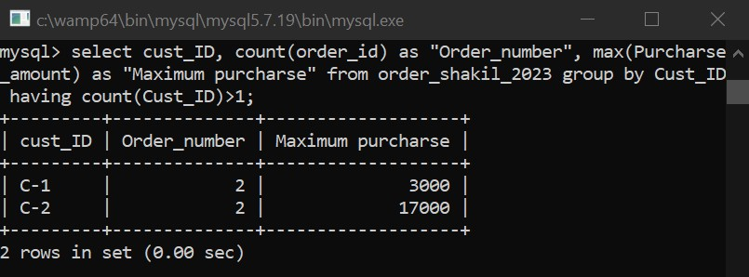

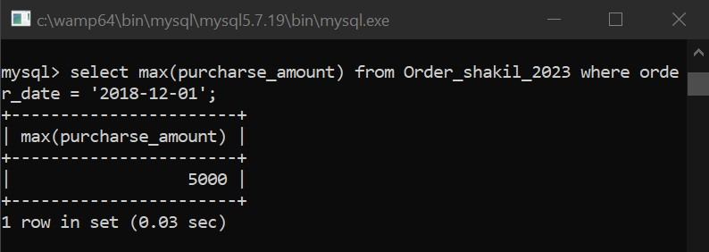**Answer - 9:**

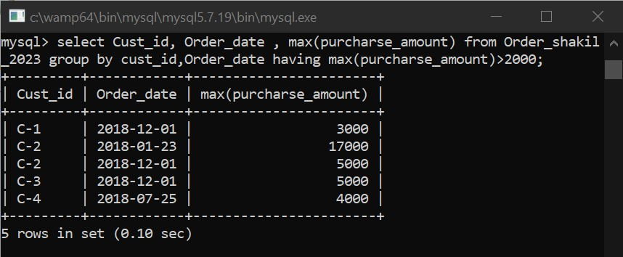**Answer - 10 :**

**Answer - 11:**

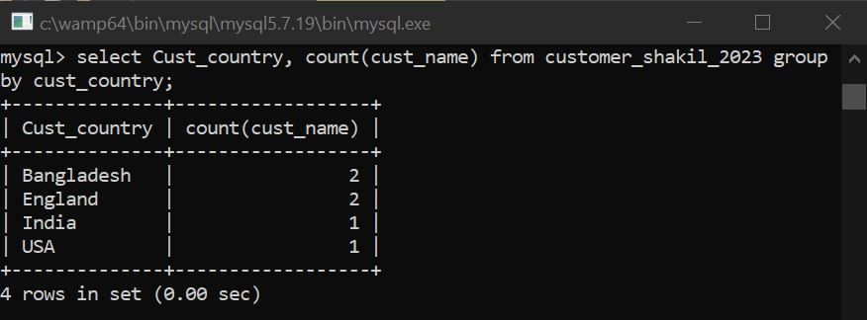

**Answer - 12:**

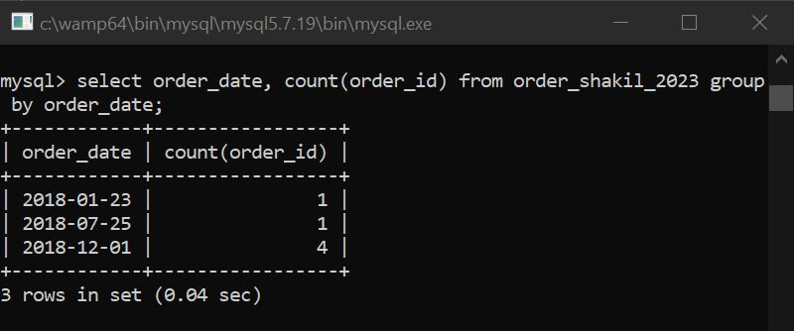

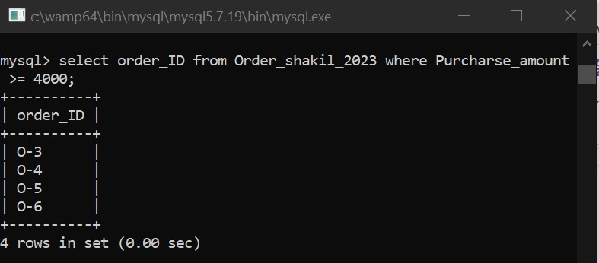**Answer - 13:**